DATE: 09.11.2018
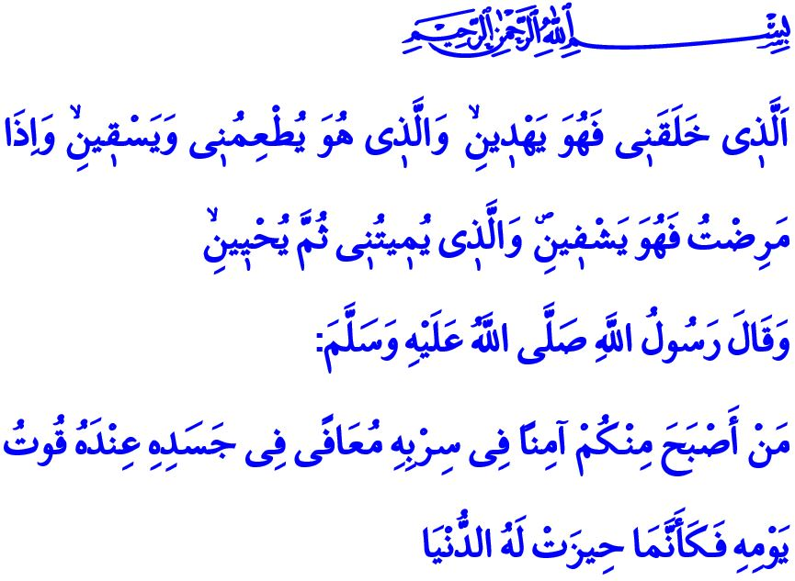
A BLESSING WORTH THE WORLDS: HEALTH
Honorable Muslims!
In the verse I have recited, the Prophet Ibrahim (as) introduces our Almighty Lord (swt) as, “Who created me, and He [it is who] guides me. And it is He who feeds me and gives me drink. And when I am ill, it is He who cures me. And who will cause me to die and then bring me to life.”
Our Prophet (saw) said in the hadith I have read: “Whoever among you wakes up in the morning secured in his dwelling, healthy in his body, having his food for the day, then it is as if the world has been gathered for him.”
Esteemed Believers!
Our religion, which is the source of mercy, invites us to respect the limits set by Allah on the one hand while setting universal principles for us to be healthy individuals and build a peaceful society on the other. The protection of life comes on top of these principles, which are indispensable for the believers. Because life, which is entrusted to us by Allah Almighty (swt), is the gate to the world of trials. Both goodness and evil can be achieved only when we are alive. To believe and act righteously proper to the purpose of our creation is possible only by being healthy both physically and mentally.
Dear Believers!
It is a matchless blessing to live, to feel the dignity and responsibility of being human, and to have the mind and will to build the world. Leaving beautiful traces behind requires to be healthy. However, we unfortunately cannot appreciate the value of life and health bestowed by Allah (swt). We squander this treasure with harmful habits, neglect, and wastefulness. We comprehend the true value of a healthy breath and body, and a peaceful heart only when it is too late. For this reason, the Messenger of Allah (saw) warns us as, “There are two blessings which many people fail (to appreciate): (They are) Health and free time.”
Honorable Muslims!
People who appreciate the value of their health protect themselves from any kind of material and spiritual damage and also pay attention to the treatment when ill. It is our responsibility to seek treatment by taking refuge in the Shafii name of Almighty Allah (swt), and to treat well the entrusted life. In this respect, our Prophet (saw) said, “Seek treatment, O slaves of Allah! For Allah does not create any disease but He also creates with it the cure.” and advised not to give up hope in recovery.
Honorable Believers!
What suits virtuous and conscientious Muslims is to protect the health of their environment as well as their own health, care for their brothers and sisters who are waiting for healing, and do their best for their treatment. The Messenger of Allah (saw), who placed great importance on praying for the patients and giving spiritual support to them by visiting, said, “Whoever relieves a Muslim of a burden in the world, Allah will relieve him of a burden on the Day of Judgement…”.
Nowadays, many patients and relatives who have lost their health due to different reasons and who are running out of treatment options are hoping for organ transplantation for a long time. It is humane and moral to donate one’s organs to others who need healing, without any material expectation in return, before the moment to leave this temporary world comes as preordained by Allah (swt). For what is essential in our religion is to save people’s lives, protect the life on earth, and support the hope.
Honorable Muslims!
So, let us not forget that every healthy moment is an invaluable blessing. Let us make it count and use wisely the days when we are young, lively, and healthy. Let us pay attention to eating halal and clean food. Let us stay away from harmful substances that threaten our health and are prohibited by our religion. Let us always listen to the following advice of our Prophet, “Appreciate the value of five things before five things come. Your young age before old age, your health before sickness, your wealth before poverty, your leisure time before being busy, and your life before death.”

Shu’ara, 26/79-81.
Tirmidhi, Zuhd, 34.
Bukhari, Riqaq, 1.
Ibn Majah, Tibb, 1.
Abu Dawud, Adab, 60; Tirmidhi, Birr, 19.
Hakim, Mustadrak, IV, 341. General Directorate of Religious Services

